Employee Form React Application
Roger Fairley Jr.
University of Arizona Global Campus
INT 304: Web Design & Development (INL2617A)
Instructor: Brian Myers
Date: May 4, 2026
Full Stack React Development
Employee Form React Application
Introduction
The purpose of this paper is to describe the process I followed to create a functional Employee Form using React, explain how React components work together to support a smooth user experience, and discuss the role of props and data flow within a React application. This assignment required me to build a form that collects employee information and displays it dynamically on the page. In completing this project, I gained hands-on experience with component structure, state management, props, and best practices for passing data in React. This paper explains the steps I took, the concepts I applied, and the technical decisions that shaped the final application.
Steps Taken to Complete the Assignment
I began the assignment by creating a new React project and setting up the required folder structure. Inside the src directory, I created a components folder and added a new file named EmployeeForm.js. I then imported React and the useState hook to manage the form’s input values. After defining the component, I added input fields for name, email, and role, along with a submit button. Each input field was converted into a controlled component by binding its value to state and updating the state through onChange handlers.
Next, I implemented the form submission logic. When the user submits the form, the application prevents the default browser behavior, validates the input, and adds the new employee to an array stored in state. I also added the ability to edit and delete employees, which required additional state variables and event handlers. To improve the user experience, I styled the form using CSS and added success and error messages to provide feedback. Finally, I used the useEffect hook to save the employee list to local storage so the data persists after a page refresh.
React Components and Their Collaborative Function
React applications are built from components, which are modular, reusable pieces of the user interface. Each component is responsible for rendering a specific part of the UI and managing its own logic. In this project, the EmployeeForm component handled both the form inputs and the employee list. Components collaborate by sharing data, responding to user actions, and updating the interface based on state changes.
React’s virtual DOM ensures smooth operation by efficiently updating only the parts of the UI that change. When state updates, React re-renders the affected components without refreshing the entire page. This creates a responsive and seamless user experience. By structuring the application around components, I was able to keep the code organized, maintainable, and easy to extend.
Understanding Props and Their Role in React
Props, short for “properties,” are a mechanism for passing data from one component to another. They allow parent components to send information to child components, enabling dynamic and flexible interfaces. Although this project used a single component, the concept of props is essential for scaling React applications.
Props enhance functionality by allowing components to remain reusable and independent. Instead of hardcoding values, components receive data through props and render content based on that data. This separation of concerns makes React applications easier to maintain and expand.
Data Flow and Rules for Using Props
React uses a unidirectional data flow, meaning data moves from parent components down to child components. Components can pass data in several ways, including props, state lifting, and context. Props are the most common method and follow two minimum rules:
- Props are read-only. A component cannot modify the props it receives.
- Data must flow downward. Parent components pass props to children, not the other way around.
These rules ensure predictable behavior and prevent components from accidentally altering shared data. When child components need to update data, they call callback functions passed down through props, allowing the parent to manage the state.
Best Practices for Passing Props
Several best practices guide the effective use of props in React. First, props should be named clearly to indicate their purpose. Second, components should receive only the data they need, keeping them focused and reusable. Third, callback functions should be passed as props when child components need to trigger state changes. Finally, developers should avoid deeply nested prop chains by using context or state management libraries when appropriate.
Following these practices helps maintain clean, readable code and ensures that components remain modular and easy to test.
Conclusion
Completing this assignment allowed me to apply key React concepts, including component structure, state management, props, and data flow. By building the Employee Form, I gained practical experience with controlled inputs, event handling, conditional rendering, and persistent storage. Understanding how components collaborate and how props support data sharing is essential for developing scalable React applications. This project strengthened my ability to design interactive user interfaces and deepened my understanding of React’s core principles.
Appendix A: New Employee Form Screenshot
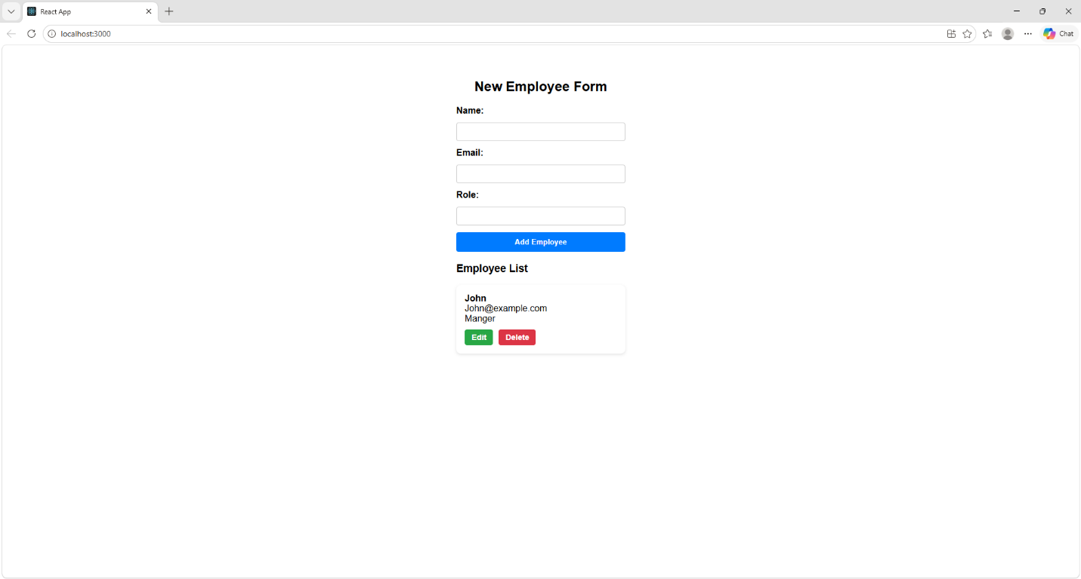
References
React. (n.d.). React documentation. https://react.dev/ Mozilla Developer Network. (n.d.). JavaScript reference. https://developer.mozilla.org

